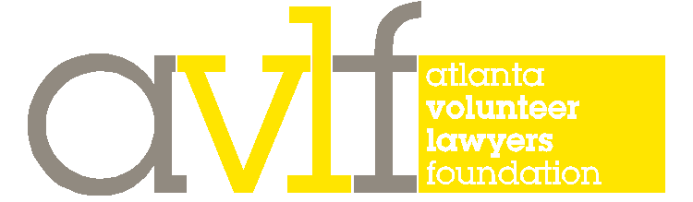
235 Peachtree Street, NE, Suite 1750, Atlanta, GA 30303 | p: 404-521-0790 | avlf.org

The Saturday Lawyer Program

Be part of supporting a critical program that could not exist without your volunteer efforts.
Join your colleagues in making a meaningful difference in the lives of fellow Atlantans.
Get the opportunity to litigate in a variety of judicial settings.
Be part of a rich legal tradition forty years in the making.
Gain valuable experience with a variety of legal issues.
Give back to the Atlanta community.

For forty years, the Saturday Lawyer Program at AVLF has provided low-income Atlantans with access to volunteer attorneys, and volunteer attorneys with a chance to do meaningful pro bono work. Those opportunities continue, with improvements that enhance the experience for all involved.

Volunteer attorneys support the Saturday Lawyer Program in one or more ways:

- Volunteer on Saturday morning (9:00 a.m. - 12:30 p.m.) to interview potential clients in person, assess their claims, and determine which cases, if any, you will accept for full representation. Most volunteers interview one or two clients each Saturday, and never more than three.

- Accept Saturday Lawyer Program cases for full representation, including those for which you conducted the initial interview and assessment on Saturday morning.

- Consult with AVLF Staff Attorneys and AVLF volunteer attorneys about issues in which you have particular expertise.

Cases accepted through this program focus on:

- Securing unpaid wages.

- Promoting habitable and safe housing and ensuring return of security deposits.

- Resolving other landlord-tenant disputes, such as illegal evictions or damage to tenants’ property caused by landlords.

[Continued on Reverse]

Based on your feedback, we continue to improve the program . . .

Instead of asking pro bono volunteers simply to show up and receive cases, AVLF now asks volunteer attorneys to partner with AVLF from the outset in assessing cases and determining whether a case is a strong candidate to be referred for full representation.

Under this model, many Saturday volunteers make a connection with our participants and accept the cases they screen for full representation. Regardless, our volunteers’ input is a valuable contribution and is critical in determining what happens with the case.

This model creates a more meaningful partnership between the program and our volunteers, and improves the quality of the cases referred for full representation—while still matching the vast majority of Saturday participants with Saturday lawyers.

If you volunteer on Saturday, you will have the benefit of:

- Succinct training materials sent beforehand covering our process, primers on key areas of law, and legal questionnaires to guide the interview.

- A short orientation and training conducted by an AVLF Staff Attorney on Saturday morning, and a chance to review and express a preference for which cases you would like to screen.

- Additional legal resource materials on common legal issues.

- Access to an AVLF and ALAS Staff Attorney on Saturday morning to assist you and answer any questions on our process or the law.

- Support staff for copying and scanning of any client documents.

- Coffee, juice and pastries!

And if you accept a case under the new Saturday Lawyer Program, AVLF will further support you with coverage by our malpractice carrier; ongoing access to our Staff Attorneys; access to our legal resources, research, and sample pleadings; access to experts for more complicated issues; and access to pro bono private investigators, process servers, forensic accountants and court reporters.

Poor and working class people are struggling now more than ever to maintain housing and financial security for their families. Please get involved in the Saturday Lawyer Program so that together we can support them during these challenging times.

If you are interested in volunteering or have any questions, please contact:

Matilde Davis Cole Thaler
678.681.6005 678.681.6007
mdavis@avlf.org cthaler@avlf.org

